FOR IMMEDIATE ATTENTION

Survey of Rural Challenges Now Open

Your answers help many rural organizations

- Survey tracks what small town people see as their biggest challenges since 2015
- Results are used by government agencies, university educators and community utilities
- Take the survey at https://SaveYour.Town/survey2020

October 27, 2020, Hopeton, Oklahoma, and Webster City, Iowa

The Survey of Rural Challenges is open for responses, now through Dec 31, at https://saveyour.town/survey2020

The survey is conducted by SaveYour.Town and SmallBizSurvival.com and is open to rural people globally: USA, Canada, Australia, New Zealand or any other country. Anyone who lives or works in small towns can answer. More than 1100 people answered the survey in previous years.

“COVID-19 has changed almost everything in 2020, and we want to ask rural people how much it has changed their priorities. Has COVID displaced other challenges like housing and internet access? That’s what we want to find out,” Becky McCray, publisher of SmallBizSurvival.com said.

Organizers Becky McCray and Deb Brown have been asking for and listening to rural challenges since 2015. Organizations like government agencies, university educators and community utilities have used the results to better serve rural people. Results from 2015, 2017 and 2019 are available at https://saveyour.town/surveynews

“The last three surveys have told us that housing, losing young people, and dead downtowns were in the top five challenges. We look forward to hearing what our rural friends will say this year,” Deb Brown, co-founder of SaveYour.Town said.

“A lot of groups claim to speak for rural people and the challenges they face. We want to hear from the rural people themselves, to get a more realistic look at the challenges,” Becky McCray, publisher of SmallBizSurvival.com said.

“Rural people have told us that the rural stories that get the most media attention aren’t really the same as their challenges. In 2017 and 2019, rural businesses said that marketing and lack of good people to hire were bigger challenges than finding a loan,” Deb Brown, co-founder of SaveYour.Town said.

Results from this year’s survey will be published at https://smallbizsurvival.com/survey

About the survey methodology
The survey will collect voluntary responses online in the fourth quarter of 2020. Respondents are expected to come from subscribers and visitors to SaveYour.Town and SmallBizSurvival.com, media coverage and publicity from cooperating groups. Respondents will identify themselves as rural by participating, and a portion will identify themselves as business owners by responding to the business question. Participants are expected to include people from the USA, Canada, Australia and other international locations.

About SaveYour.Town
SaveYour.Town believes small towns can be saved by their own people using their existing assets. Deb Brown and Becky McCray joined forces in May 2015 to help small towns and rural communities thrive. They deliver speeches and presentations internationally, lead site visits and community brainstorming sessions, and create online videos and short courses of practical steps that can be put into action right away.

About Small Biz Survival
SmallBizSurvival.com publishes practical articles for rural small businesses. It was founded in January 2006 by Becky McCray from Oklahoma. Over the years, it has achieved top ranking among small business blogs on sites like Technorati, Invesp BlogRank and BizHumm, and it continues to appear on lists of top small business blogs. For her work as publisher, McCray has been named one of the Power Players in Technology Business Media and a Small Business Influencer Journalist four times.

About Becky McCray
Becky McCray is a lifelong small-town entrepreneur. As co-founder of Save Your.Town, she shares insights from her real-world experience as a business owner and cattle rancher. Throughout her career, rural has been the focus. She managed a retail store, served as city administrator and nonprofit executive, bought and sold antiques and taught classes in business and technology. Her practical perspective is featured at her highly-ranked website, Small Biz Survival, and in her award-winning book, Small Town Rules. She’s been featured and quoted in books, newspapers, magazines, blogs, podcasts and university publications. She makes her home base in Hopeton, Oklahoma, a community of 30 people.

About Deb Brown
Deb Brown is a small town enthusiast and expert for small towns. Her practical approach for getting communities into action right away has been shared at national conferences, local visits, service organizations and everything in between. Her wealth of experience includes foreign casualty insurance underwriting, bartending, retail management, selling knives around the US, leading a chamber and working with small towns. Deb has lived in tiny towns, small towns, small cities and a major metro city. Yet, she’s come home to a small town and travels to many other rural communities to help. She collaborates with Becky McCray at SaveYour.Town and has her own business www.BuildingPossibility.com.

Website and social media links
- Survey Results and News Room: https://saveyour.town/surveynews
- LinkedIn: Becky McCray, Deb Brown
- Twitter: @BeckyMcCray, @DebWorks, @SBSurvival, @SaveYourTown
- Instagram: @BeckyMcCray, @DebraInIowa, @SaveYourTown
- Facebook: Small Biz Survival, SaveYour.Town

Sample wording for social media posts:
- Internet? Housing? Good workers? COVID? What are the real priorities in your town? Share on the Survey of Rural Challenges https://SaveYour.town/survey2020
- What are the real challenges in your town? Speak your mind on the Survey of Rural Challenges https://SaveYour.town/survey2020
- How has 2020 changed priorities in your small town? Share on the Survey of Rural Challenges https://SaveYour.town/survey2020
- Speak up, rural America! Share your situation on the Survey of Rural Challenges https://SaveYour.town/survey2020

Logos

Downloadable at https://saveyour.town/surveynews

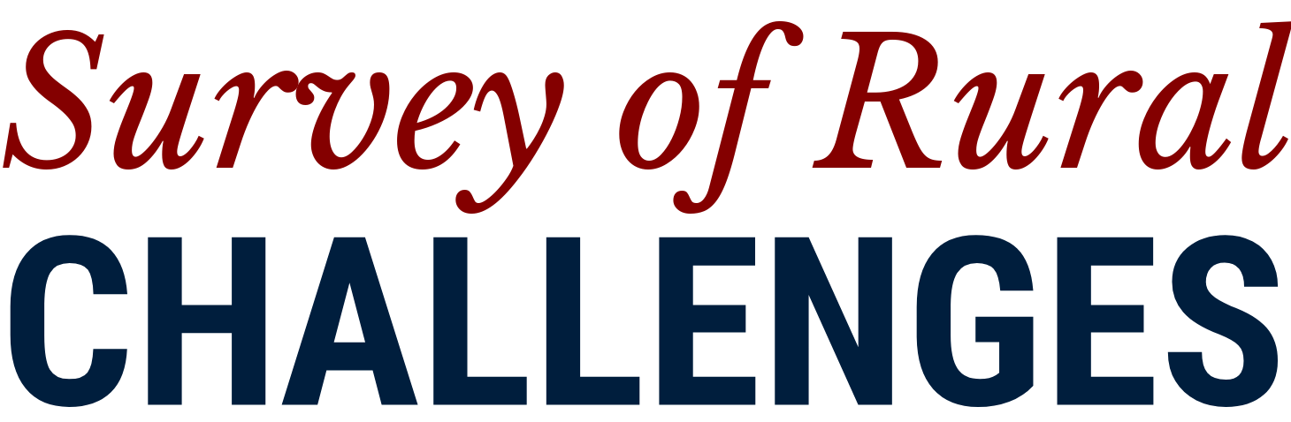

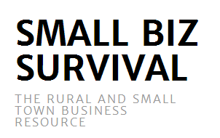

Contact:
- Deb Brown deb@saveyour.town
- Becky McCray becky@smallbizsurvival.com

